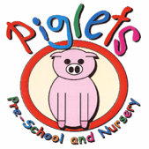
Piglets Day Nursery
Price List from September 2024

Non – Funded Children (All ages)*
Hourly Rate | £7.00
Breakfast | £1.00
Snack | £1.00
Lunch | £3.00
Tea | £3.00
Sibling discount ** | 15%
Full time discount *** | 15%

Funded Children (All ages)*
Hourly Rate for hours over funding | £7.00
Breakfast | £1.00
Snack | £1.00
Lunch | £3.00
Tea | £3.00
Sibling discount** | 15%
Full time discount *** | 15%

All Parents will request hours between the opening hours of
7:30 – 6:00. Hours requested must be adhered to consistently. If eligible, the appropriate amount of funding will be applied weekly. Minimum session requirement: 4 hours per session.

*Piglets reserve the right to review and amend the fees at any time*
**Discount only available on full days also attended by the sibling**
***Full time discount – 5 days per week attendance. Children will only be entitled to one discount, either sibling or full time***

